DMK Sample 2, 2022 “% Alteration Calculations”

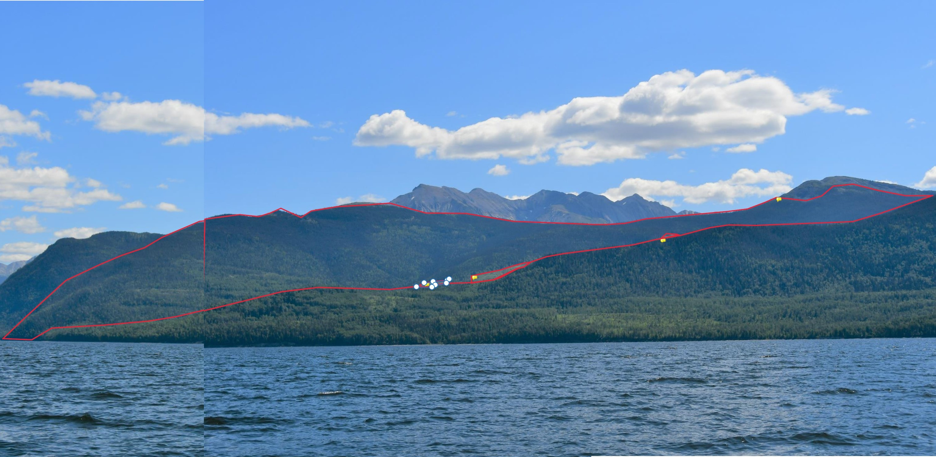

Photo Location: View Point 26, Finlay Bay Viewpoint GPS Coordinates/Elev: 56.025 N, 123.815 W 673m
Photo Number(s) / Date Taken: July 21, 2022 Focal Length Used (mm): 35mm Nikon DX/ APS-C

% of Landform Altered by Recent Openings: 1.1 |  | % of Landform with Site Disturbance Outside Openings: 0 |  | % Non VEG Contribution of Old Openings: 0

Sample Information: Visual Landscape Inventory Information:
Forest District | District of Mackenzie |  | VLI Polygon No. | 541
Field Sampling Date | 07/21/2022 |  | VLI Update Date | 03/31/1996
Licensee Name | BCTS |  | EVC / VAC / VSC | P/M/3
License No. | A90935 |  | EVQO | M
CP No. / Block No. | 5 |  | Date of VQO Establishment | 03/31/1996
Opening ID | 1731574 |  | Source Document | EVQO from FPPR 9.2/Not recommended as scenic area by LRMP but currently known/MFR recommended VQO = PR

